12/12/2016

George Pappas

waubonsee community college

*Should We Increase Minimum Wage?*

George Pappas

Mrs. Dharmasankar

Macro Economics

12 December 2016

Should We Increase Minimum Wage?

Many people in the United States believe that increasing the minimum wage will allow more people to spend money, which in turn will create more money in circulation. However, from the research I’ve done, that’s not the case. Quite the opposite will happen, many workers will be laid off due to the fact that companies will no longer have the funds to pay them. If the company chooses to keep their employees, then the cost of their product will rise so they can have enough money to pay their workers. The article I found interesting is by “The Wall Street Journal” and it explains the topic of increasing the minimum wage. The topic of increasing the minimum wage should be important to everyone in the economy simply because it will affect everyone in the long run. Increasing the minimum wage will get many people unemployed and could also change the cost of many items which will in turn increasing the cost of living. I choose this article because in the near future I will be looking for my first job and I would like to be informed as to how much I should get paid. If we as a state were to increase the minimum wage, then it would be much harder for someone that has no work experience to find his/her first job. The article, *Push for $15 Minimum Wage Heats Up*, explains why some people are for increasing the minimum wage and explains their points and ideas. It also explains the opposing view, the view of why we shouldn’t increase the minimum wage. It takes also takes the view from the businesses as to what they think about raising the minimum wage, of course they are not for it because they will make less money and loss their productivity.

The first aspect of increasing minimum wage is the effect on inflation. For those of you who don’t know, inflation in economic terms is defined as “a general increase in prices and fall in the purchasing value of money.” This doesn’t mean that all prices ill in fact rise, however, the average of prices will rise. Some prices will go up, some may increase a lot, some may increase a little, and some prices might even go down.

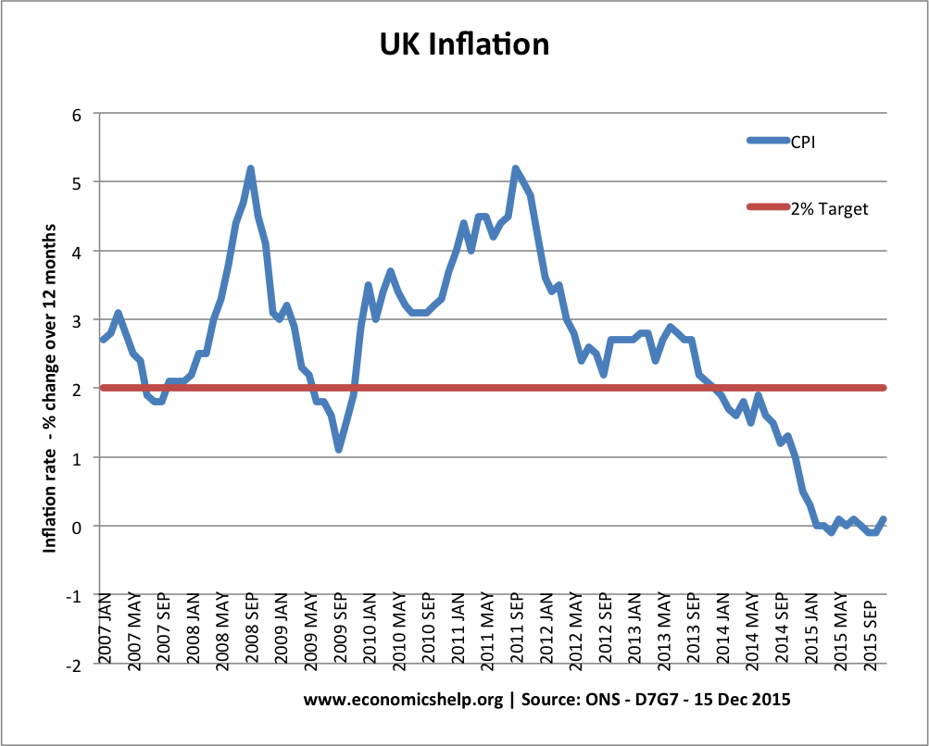

As you can see from the graph above, they (whoever they may be) has a target goal of 2%. However, the CPI (Consumer Price Index) is, for the most part, above their targeted goal of 2%, this is called inflation. If the CPI line was under the 2% target this would be called deflation, which (in this graph) started to occur September of 2013. If minimum wage was increased, then companies everywhere will have to increase the prices of their products to continue making the same amount of profit.

So what happens when the minimum wage is increased? Consider the situation in restaurants that have a middle-income clientele. Restaurant owners, facing a higher wage bill, would like to pass the costs on to their customers. But their customers are people whose incomes have not been affected much, if at all, by the higher minimum wage. So if prices at the restaurants go up, these people will buy less and the restaurants will now lose some profits. They may raise prices a bit, but not much. Whatever they do, the restaurant owners will have to, if you’ll pardon the term, eat some of the increased costs. (Macewan)

This will in turn slow the economy down because people are spending less money. People would rather keep their money, save up, and buy something worth their hard-earned money.

Research will also suggest that the cost of living would also increase due to the rise in prices. The cost of living is defined as “the level of prices relating to a range of everyday items.” Because more companies and businesses need to pay their workers more they have two choices – one would be to cut down on the number of workers they have which in turn will lower their productivity, or they can (as stated in the last paragraph) take it out on the consumer and charge them more, which will also increase the cost of living. “The cost of living in the New York City metro area was 22.3% higher than the national average in 2013, according to the latest data available from the Commerce Department. It was 20.3% greater than average in the San Francisco region and 17.7% higher in the Los Angeles area.” (Morath)

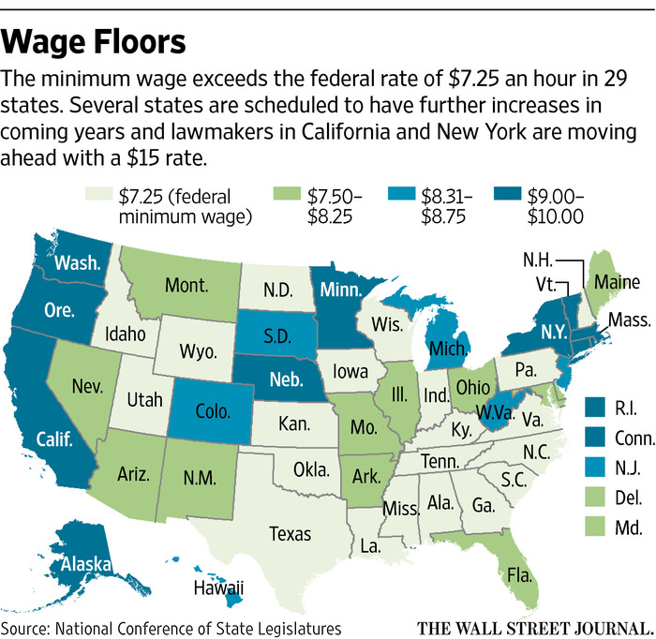

With the help of the quote and the graph, we can rule out that the price of living is directly correlated to the minimum wage rate. New York, for example, has a rather high cost of living rate and also has a higher than average minimum wage rate.

Increasing the minimum wage will also have an effect of the labor force. Not only will companies hire less people because they simply can’t afford to pay more workers, but they will also expect more out of their workers because they are getting paid much more than they were previously.

Employers may also raise their expectations of workers, including requiring greater work effort, punctuality, and less absenteeism in the workplace. Employers may increase the hiring standards for entry-level jobs, such as requiring more education or work experience. If higher minimum wages also reduce voluntary job separations, this reduces the stock of job vacancies, making it more difficult for job-seekers to find jobs. (Wessels)

This will in turn make it much harder to find a job for people with no previous work experience, people that are not as capable to work as their competition, and people who are less skilled than the person next in the unemployment line.

In conclusion, I feel that increasing the minimum wage will do more harm than good. It’s going to make it much harder for me personally to find a job when it comes time. For the rest of the economy, many companies and business will be forced to lay off many good workers if they cannot afford to pay them. Some people may think that increasing the minimum wage will be helping the economy, when in reality, it will be doing quite the opposite.

Works Cited

Macewan, Arthur. "The Minimum Wage and Inflation." The Minimum Wage and Inflation |

Dollars & Sense. N.p., July-Aug. 2014. Web. 14 Dec. 2016. www.dollarsandsense.org

/archives/2014/0714macewan.html>.

Morath, Eric, and Erica Orden. "Push for $15 Minimum Wage Heats Up." The Wall Street

Journal. Dow Jones & Company, 31 Mar. 2016. Web. 14 Dec. 2016. www.wsj.com

/articles/race-for-15-minimum-wage-heats-up-1459451862>.

Wessels, Walter. "The Effect of Minimum Wages on the Labor Force Participation Rates of

Teenagers." Employment Policies Institute. N.p., June 2001. Web. 14 Dec. 2016.

<https://www.epionline.org/studies/r32/>.